Tribhuvan University Institute of Engineering Thapathali Campus

Submitted By:
Bishal Maharjan[078/MSIISE/03]
Submitted To:
Hari Aryal

August 26, 2022

INTRODUCTION

Owning a house has been a symbol of financial and social status at present. Nepal Rastra Bank’s data indicate land prices increasing 27.7% each year resulting in doubling of price in 3.5 years. In this context, it would be convenient for everyone to have a price estimate of their dream home based on their preferences.
Conventional way of estimating house price in Nepal has always been the consultancy with the brokers (real estate agents). But the manual process is inconvenient and costly, sometimes leading to quick decisions as per the agent’s influence. That is where an electronic platform will come handy to have a general idea of house price based on its features. The same will be applied to anyone willing to sell their house.
Machine learning models are dexterous in problems where mathematical models cannot be built manually in case the exact relationship between the parameters is hidden. This ability can be exploited in predicting house prices by letting the model derive the appropriate relationship between those parameters out of the data fed.
ML models for house price prediction in a locality or a nation will require data of established house prices in the locality. In Nepal, there are no such models developed using domestic data. This project will aim to fill the void and necessity.

OBJECTIVE

- To develop a linear regression model incorporating different attributes of a house using a labeled dataset
- To estimate price of a house given the different attributes using the model
- To test the conventional hypothesis about housing price estimation i.e. the price mainly depends on size of property and location
- To develop a scientific estimation of house price in contrast to the traditional way which merely depends on cost and sale price
- To reduce the cases of overvaluation or undervaluation of property by providing a reasonable estimation
- To eradicate the possibility of buyers and sellers being trapped by real estate agent’s influence

LITERATURE REVIEW

As aforementioned, there are no ML models for house price prediction using Nepalese data. This project may develop such a model for the very first time in the context of Nepal.
Nevertheless, similar projects have been accomplished in the global context using housing price data of many regions.
Ozancan Ozdemir developed a predictive model for house prices using tree based methods. Those methods included Random Forest, Gradient Boosting, etc. Ames House Price dataset available in Kaggle was used.
Anand G. Rawool, et al. tested four ML algorithms namely, Linear Regression, Decision Tree, K Means, and Random Forest Regression on housing price data available on real estate websites. Random Forest was found out to provide maximum accuracy.
Imran, et al. used a Pakistani housing market dataset scraped from the web to test on some algorithms like Linear Regression, Support Vector Regression, and Deep Learning Network. SVR performed the best for the case.
Nissan Pow, et. Al from McGill University analyzed the real estate property prices in Montreal from data extracted from a couple of websites. They compared regression models such as Linear Regression, SVR, kNN, and Random Forest on the data and found out the later produced minimum error.

Proposed Methodology
System Block Diagram

Housing Data
Collection
Data
Cleansing
Feature
Engineering
Training
the Model
Model Evaluation and Validation
Model
Deployment

- Housing Data Collection: Major source of data will be the housing websites of Nepal. Data will be extracted from the sites in the desired format.
- Data Cleansing: Cleansing will involve removal of unwanted attributes from the data, getting rid of redundancies.
- Feature Engineering: It involves handling missing data (categorical and continuous), feature encoding, normalization and standardization, etc.
- Training the Model: Linear regression model will be trained with the refined and processed dataset with 4:1 train to test ratio.
- Model Evaluation and Validation: Metrics like accuracy, root mean squared error, and others will be evaluated to assess the performance. K-fold cross validation for validating the results.
- Model Deployment: Final model will be used to predict house prices in real-scenario.

Traditional ML Algorithm To Be Used
Linear Regression will be the ML algorithm to be used for this project. It is because of the continuous nature of the variable to be predicted (i.e. dependent variable). Being simple and easy to use, using LR model allows more focus on feature engineering which is a must for this project.
Support Vector Regression will also be modeled for comparing the performance against LR.

Validation
K-fold cross validation technique will be used to validate the performance of the model across the dataset with varied number of folds i.e. k.

DATASET EXPLANATION

The project will involve constructing a dataset out of Nepalese housing price data available in websites by extracting via web scraping and using their open APIs if available. Help from real estate agencies is being sought to obtain more realistic data which can be used for testing the model.
The dataset will be prepared in ‘.csv’ format before importing to the ML program. Irrelevant and redundant columns in the spreadsheet will be removed manually.
Number of Instances :Around 5000
Number of Features: 12
Target Feature: Price of House (Continuous Value)
Other Features: Number of bedrooms, Number of bathrooms, Number of floors, Number of vehicles that can be parked, Direction the property is facing, Year of construction, Area of Property, Road width, Road Type, Number of Amenities, Location
The dataset thus constructed contains both categorical and continuous data in various features. Categorical data will be encoded to numerical value before being fed to the model.
Missing data is another issue to be dealt with. Such cases will be handled by predicting the missing data using Multiple Imputations using Chained Equations.

EXPECTED RESULTS

The goal of the project is to develop a model that predicts the price of a property (house) based on its attributes. After supervised learning using the dataset constructed as mentioned, the model will be competent to do so. The model will expect the values for each of the features to be provided in a prescribed type in order to process the prediction. Predicted value i.e. the estimated price of the property will be displayed.
It is important to note that the predicted price of the house will be from the seller's perspective because of the nature of the source used to obtain the dataset.
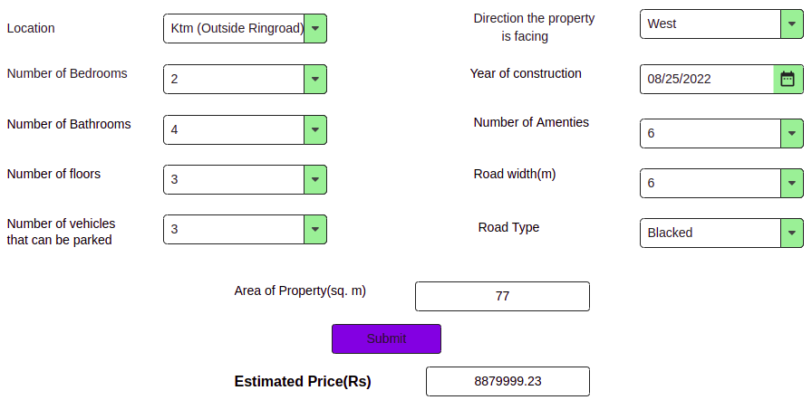
Fig:Expected Output

References
- Nepal Rastra Bank, Economic Research Department, “Housing Price Index Survey Report”, 2021.
- Ozancan Ozdemir, “House Price Prediction Using Machine Learning: A Case in Iowa”, February 2022
- A.G. Rawool et al., “House Price Prediction Using Machine Learning”, IRE Journals, Volume 4, Issue 11, May 2011
- Imran, et al., “Using Machine Learning Algorithms for Housing Price Prediction: The Case of Islamabad Housing Data”, Soft Computing and Machine Intelligence Journal, Vol 1, Issue 1, 2021
- Nissan Pow, et al., ”Applied Machine Learning Project 4 Prediction of real estate property prices in Montreal”, 2014

